**PARK RIDGE STATE HIGH**

**SCHOOL**

**UNIFORM SHOP**



**JUNIOR**

Day Polo

$35

Stretch Shorts

$30

Day Polo

$35

Stretch Shorts

$30

M

crofibre Jacke

$30

Microfibre Track Pants

$30

Microfibre Shorts

$15

**MISC**



**FORMAL**

**SENIOR**

Blouse

$35

Skirt

$35

White Shirt

$35

Shorts

$35

Microfibre Jacket

$45

Microfibre Track Pants

$35

Jumper

$28

**WINTER**

Trucker Cap

$9

Bucket Hat

$9

Scientific Calculator

$15

USB 16GB

$10

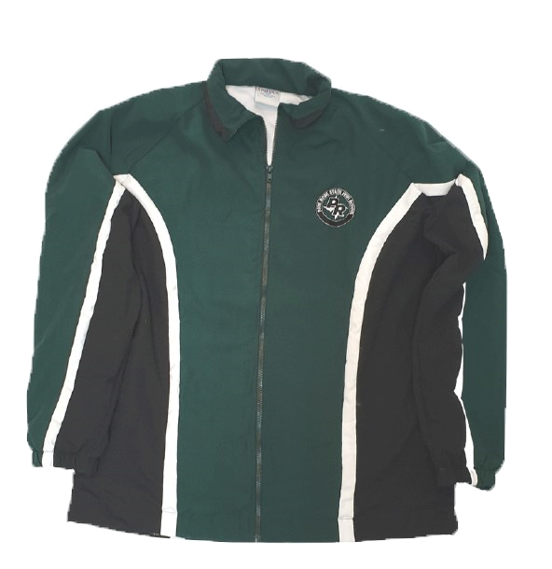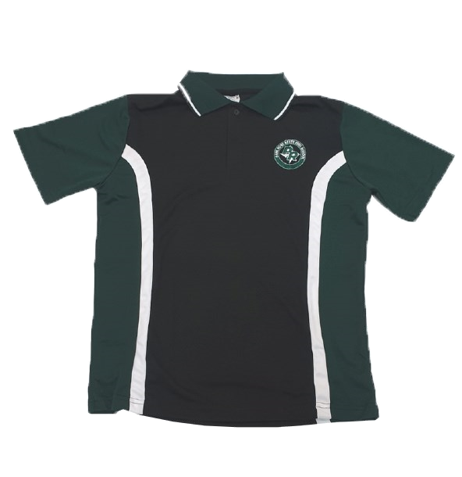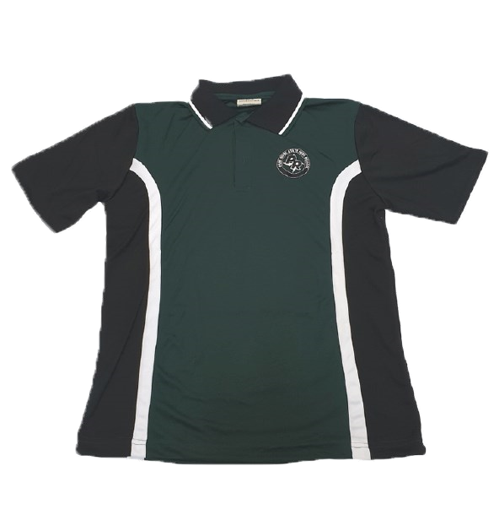

***EXCELLENCE IN ALL WE DO***